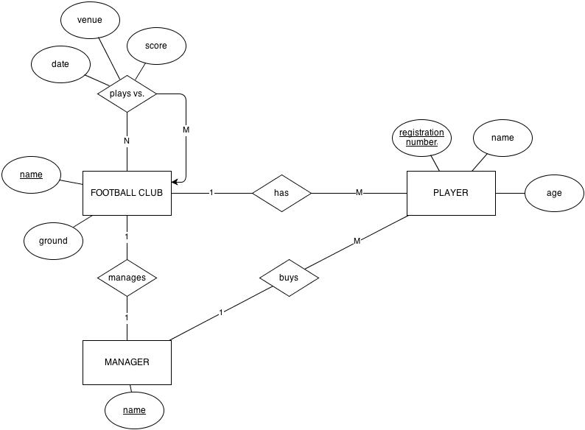
football club(nameFC(FK de player), ground,nameM)
manager(nameM(FK de player),nameFC)
player( registrationNumber, name, age, nameM,nameFC)
plays vs(date, venue, score,nameFC1,nameFC2)

